國立臺灣師範大學知音劇場
Zhi-Ying Theater, National Taiwan Normal University

10644台北市大安區和平東路一段129-1號(綜合大樓)10樓
Comprehensive Bldg. 10F., No.129-1, Heping E. Rd. Sec. 1, Taipei City, Taiwan

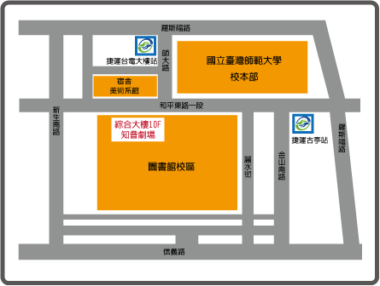
◆ 捷運 淡水線〈紅線〉、中和線〈橘線〉、新店線〈綠線〉
於『古亭站』下車，五號出口直行約八分鐘即可到達
◆ 公車 3、15、18、74、235、237、672、278、和平幹線
於『師大站』或 『師大夜市站』下車
Direction to Zhi-Ying Theater by MRT
1. Take the Xindian Line (green line) or Nanshijiao Line (yellow line)
2. Get off at Guting Station
3. Take the Exit 5
4. Walk alongside Heping East Road for around 8 minutes (Zhi-Ying Theater is located at the 10 Floor of Comprehensive Building at 129-1 Heping E. Road Sec.1)

